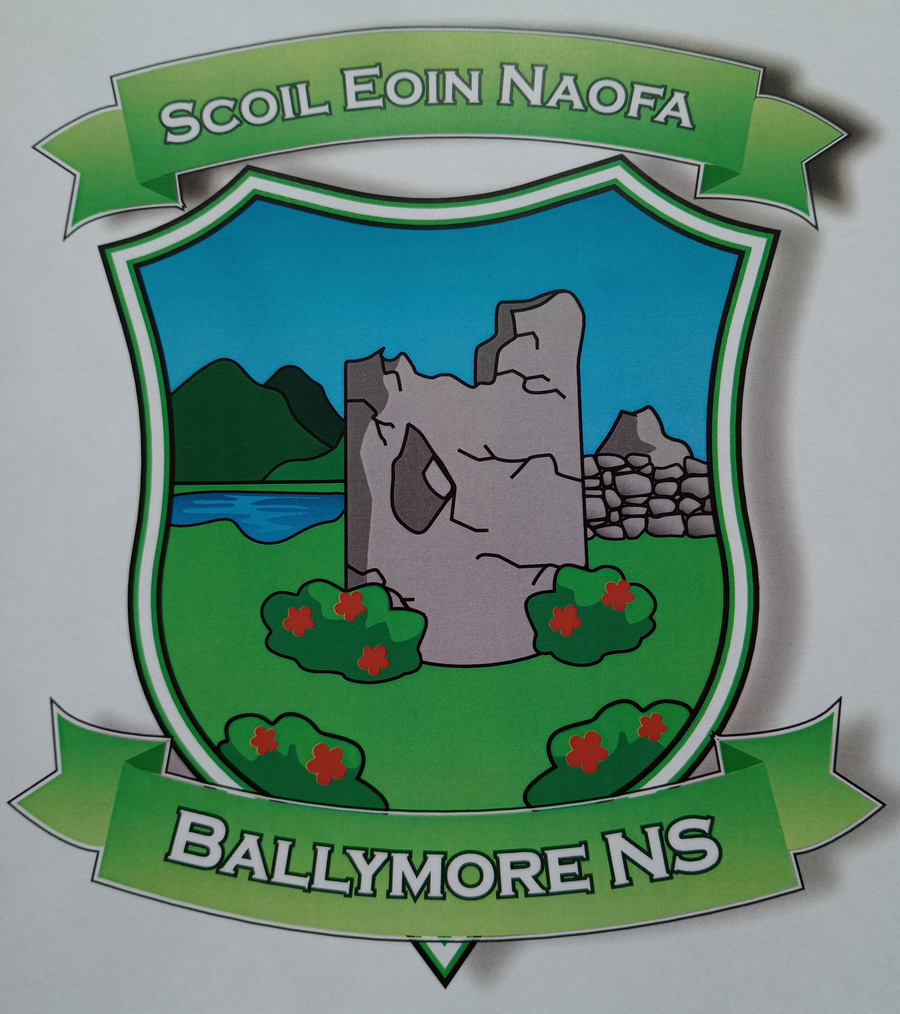
Critical Incident Policy & Plan

Critical Incident Policy
At all times, Ballymore NS aims to protect the wellbeing of its students and staff by providing a safe and nurturing environment as defined in our Mission Statement. The Board of Management, through the Principal, has drawn up the following Critical Incident Management Plan as one element of the school’s policies and plans.

The aim is to establish a Critical Incident Management Team (CIMT) to steer the development and implementation of the plan.

Aim
The aim of the Critical Incident Management Team (CIMT) is “to help school management and staff to react quickly and effectively in the event of an incident, to enable them to maintain a sense of control and to ensure that appropriate support is offered to students and staff”. Having a good plan will also help ensure that the effects on the students and staff will be limited. It will enable the school to return to normality as soon as possible.

Definition of Critical Incident
The staff and management of Ballymore NS recognise a critical incident to be “an incident or sequence of events” that overwhelms the normal coping mechanism of the school”.

Critical incidents may involve one or more students or staff members, their family members or members of the local community e.g.

- The death of a member of the school community through accident, violence, suicide or suspected suicide or other unexpected death
- An intrusion into the school
- An accident involving members of the school community
- An accident/tragedy in the wider community
- Serious damage to the school building through fire, flood, vandalism, etc.
- The disappearance of a member of the school community.

Creation of a Coping Supportive and Caring Ethos in the School
Ballymore NS has put systems in place to help to build resilience in both staff and students through our SPHE/RSE programmes, thus preparing them to cope with a range of life events. These include measures to address both the physical and psychological safety of the school community.

Physical Safety
In the area of physical safety the school has put in place the following:

- Evacuation plan formulated
- Regular fire drills occur
- Fire exits and extinguishers are regularly checked
- Pre-opening supervision in the school on days of inclement weather e.g. frost, rain, snow
- Secure doors accessed by bell only during school hours
- General school rules under the school’s behaviour policy to ensure all pupils have a safe environment.

Psychological safety
The management and staff of Ballymore NS also use available programmes and resources to address the personal and social development of students, to enhance a sense of safety and security in the school and to provide opportunities for reflection and discussion.

Social, Personal and Health Education (SPHE)
- It is integrated into the work of the school. It is addressed in the curriculum by including issues such as grief and loss; communication skills; stress and anger management; resilience; conflict management; problem solving; help-seeking; bullying; decision making and prevention of alcohol and drug misuse. Promotion of mental health is an integral part of this provision
- Staffs have access to training for their role in SPHE
- Staffs are familiar with the Child Protection Guidelines and Procedures and details of how to proceed with suspicions or disclosures
- Books and resources on difficulties affecting the primary school student are available
- The school has developed links with a range of external agencies e.g. HSE/Community Care/NEPS
- Inputs to students by external providers are carefully considered in the light of criteria about student safety, the appropriateness of the content, and the expertise of the providers
- The school has a clear policy on bullying and deals with bullying in accordance with this policy
- There is a care system in place in the school
- Students who are identified as being at risk are referred to the designated staff member (e.g. support teacher). Concerns are explored and the appropriate level of assistance and support is provided. Parents are informed, and where appropriate, a referral is made to an appropriate agency
- Staffs are informed about how to access support themselves.

Critical Incident Management Team (CIMT)
A CIMT has been established in line with best practice. The members of the team were selected on a voluntary basis and will retain their roles for at least one school year. The members of the team will meet annually to review and update the policy and plan. Each member of the team has access to the schools Critical Incident Management Folder which include all of the following:

- A copy of the Critical Incident Management Team/and the Key Roles
- An emergency contact list/school staff contact list
- A copy of the duties of each team member
- A copy of the Board of Management members & contacts
- An Action Plan Template.

Key Roles and Responsibilities of the CIMT
- Team Leader
- Garda liaison
- Staff liaison
- Student liaison
- Parent liaison
- Community liaison
- Media liaison
- Administrator.

The Following are the Key Responsibilities of Each Role

Team Leader
- Alert the team members to the crisis and convenes a meeting
- Co-ordinate the tasks of the team
- Liaise with the Board of Management; DES; NEPS; SEC
- Liaise with the bereaved family.

The Deputy Principal will assure this role in the absence of the team leader.

Garda Liaison
- Liaise with the Gardaí
- Ensure that information about deaths or other developments is checked out for accuracy before being shared.

Staff Liaison
- Lead briefing meetings for staff on facts as known, give staff members an opportunity to express their feelings and ask questions and outline the routine for the day
- Advise staff on the procedures for identification of vulnerable students
- Provide materials for staff (from the Critical Incident Folder)
- Keep records of students seen by external agency staff
- Look after setting up and supervision of ‘quiet’ room where agreed

Community/Agency liaison
- Maintain up to date lists of contact numbers - members of the Parents Council, emergency support services and other external contacts and resources
- Liaise with agencies in the community for support and onward referral
- Check credentials of individuals offering support
- Co-ordinate the involvement of these agencies
- Remind agency staff to wear name badges
- Update team members on the involvement of external agencies

Parent Liaison
- Visit the bereaved family with the team leader
- Arrange parent meetings if held - Facilitate such meetings, and manage ‘questions and answers’
- Set up room for meetings with parents
- Meet with individual parents
- Maintain a record of parents seen
- Manage the ‘consent’ issues in accordance with agreed school policy
- Ensure that sample letters are typed up, on the school’s system and ready for adaptation
- Provide appropriate materials for parents (from their Critical Incident Folder)

Media Liaison
- In advance of an incident, will consider issues that may arise and how they might be responded to (e.g. students being interviewed, photographers on the premises, etc)
- In the event of an incident, will liaise where necessary with relevant teacher unions etc
- Will draw up a press statement, give media briefings and interviews (as agreed by school management)

Administrator
- Maintenance up to date telephone numbers of:
  - Parents or guardians
  - Teachers
  - Emergency services
- Take telephone calls and note those that need to be responded to
- Ensure that templates are on the school’s system in advance and ready for adaptation
- Prepare and send out letters, emails and faxes
- Photocopies materials needed
- Maintains records

Record Keeping
In the event of an incident, each member of the team will keep records of phone calls made and received, letters sent and received, meetings held, persons met, interventions used, material used etc. The school secretary will have a key role in receiving and logging telephone calls, sending letters, photocopying materials, etc

Confidentiality and Good Name Considerations
The management and staff of Ballymore NS have a responsibility to protect the privacy and good name of the people involved in any incident and will be sensitive to the consequences of any public statements. The members of the school staff will bear this in mind and will seek to ensure that students do so also. For instance, the term “suicide” will not be used unless there is solid information that death was due to suicide, and that the family involved consents to its use. The phrases, ‘tragic death’ or ‘sudden death’ may be used instead. Similarly, the word ‘murder’ should not be used until it is legally established that a murder was committed. The term ‘violent death’ may be used instead.

Critical Incident Rooms
In the event of a critical incident:

- The Staff Room will be the main room used to meet the staff
- The Assembly Hall for meetings with students
- The Parent Room for parents
- The Assembly Hall for media
- The Parents Room for other visitors

Consultation and Communication Regarding the Plan
All staff were consulted and regard was given to their views in the preparation of this policy and plan. Students and parent representatives were also consulted and asked for their comments. Our school’s final policy and plan in relation to responding to critical incidents has been presented to all staff. Each member of the critical incident team has access to a personal copy of the plan. All new and temporary staff will be informed of the details of the plan by a Staff Liaison member.

The plan will be updated annually in the month of October.

Chairperson of the BoM: Signed - ______________________ Date - ______________

Critical Incident Management Team for Scoil Eoin Naofa

Team Leader: __________________________
Garda liaison: __________________________
Staff liaison: __________________________
Student liaison: __________________________
Parent liaison: __________________________
Community liaison: _______________________
Media liaison: __________________________
Administrator: __________________________

