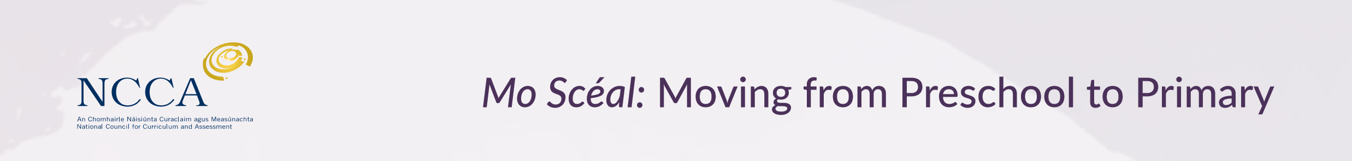

ncca.ie/earlychildhood
primar
developments
foráis sa bhunscolaíocht
Resources to support your child’s learning and development in preparing for primary school
Starting primary school is an important and exciting time for young children and parents alike. Many parents wonder if there is anything that they can do at home to support their child’s learning as he/she gets ready for junior infants, and the answer is ‘Yes, there is’!
This information sheet provides links to videos and tip sheets with some practical advice for parents.
Helping your child to learn through play and language
 | Providing opportunities for your child to play and to talk is an important way that you can support his/her learning. Watch this two-minute video to learn more about this. Key messages for parents on supporting children’s learning and development from birth to 6 years
 | Providing opportunities for your child to play helps him/her to build relationships, be creative, learn about numbers, think, use language and use small and large muscles. Read this tip sheet, Information for parents: Learning and developing through play (2 ½ to 6 years) for ideas on how to help your child to learn and develop through play.
 | Taking part in activities based on your child’s interests is another important way to support his/her learning. Watch this two-minute video, Supporting learning and development of children aged 4-8 years: key messages for parents
 | Listening to your child, having conversations and reading together, and pointing out words and notices at home and in your community will introduce him/her to the world of language—spoken and written. Read this tip sheet for more practical ideas on introducing reading and writing to your child in an age-appropriate way: Helping your young child to read and write (3-6 years).
 | Visiting the library regularly will help your child to learn about books and how to use them. Your child will enjoy having a story before bedtime, and it will give you a chance to relax with him/her, to talk about the story and to introduce new words and ideas. Here is a link to a list of books that are good for this age group: Books that promote discussion: Suggested picture book list for young children (3 to 6 years)
 | Introducing your child to useful words and phrases in Irish before they begin school will be helpful for him/her. Here is a tip sheet that can help: Introducing Irish to preschool children (3-6 years)
ncca.ie/earlychildhood
primar
developments
foráis sa bhunscolaíocht
Helping your child to learn about maths
 | If you want to find out about ways to support your child’s maths skills at home then watch this two-minute video: Supporting mathematics: key messages for parents (3-6 years) Here you will learn about the importance of your child playing with blocks, sticks and other similar items. Talking about shapes, patterns and measurements is also great so be sure to let them help out when you are cooking, keeping a watchful eye on the score at a match, or doing the grocery shopping.
 | Your child has been learning about maths since they were born. Talking to your child and letting him/her take part in everyday activities like helping with the shopping, setting the table, pairing socks will help him/her with maths. Read this tip sheet for more ideas on helping your child to understand maths: Helping your young child with maths (3-6 years)
 | Maths is everywhere and one area of this is measure. Having the words to talk about measure will be helpful for your child. Read this tip sheet for examples of useful words as well as advice on how you might help your child to understand what the measurement words mean: Information for parents: Learning about measure (3-6 years)
Supporting your child’s physical development
 | Developing movement skills like climbing, balancing and kicking a ball are important for your child. Read this tip sheet to find out ways to improve your child’s physical development: Nurturing children’s physical well-being through Fundamental Movement Skills (3-6 years)

